2014 SHELF Survey: Bitter Crab – Kodiak-Pathobiology

The goal is to collect 200 frozen crab samples (legs) within each index site. There are 3 index sites assigned to *Chionoecetes opilio*, and 3 to *C. bairdi*. Within each index site, there are 10 stations (see below & index station map). Collect 20 legs of the specified species at designated stations. If you cannot collect 20 at a station, make up the difference at the next station w/in the index site.

1. Refer to BCS Index Site and Station map. When on a station, randomly sample crabs regardless of sex. See below and the index station map for *C. opilio* and *C. bairdi* maximum target sizes. It is *very* important to obtain 20 crabs/station! Crab leads: please keep in touch with each other to ensure that the 200 crab collection goals are met at each index site.
2. Crabs should be chosen at random during measuring. As the “crab measurer”, pick out a crab and alert the “data entry person” that this crab will be used for BCS project. Then request a crab number, which will be the data entry Record Number from the database. Grab a bag from the “patho bag bundle”, on the pre-printed label write the Record Number in the SAP Crab No. line, as well as the haul number (see tag example below). Remove a leg: either break off an entire leg (claws are OK) or use scissor to cut (we need at least 1” length of muscle). Drop used scissors in beaker of fresh water (don’t let blood/tissue dry on scissors). For small (<30mm) crabs, collect multiple legs, or freeze whole crab. Place leg inside bag with label on the inside facing out.
3. At the end of the haul, collect all 20 crab leg bags and place inside a larger bag. Write the haul number on a pre-printed label and place the label on the inside of the haul bag facing out. Put bags in freezer inside a freezer box. Rinse off all used scissors in fresh water to avoid contaminating following crab.

*If both biologists stay on deck at an index station, or if time is an issue,* ***whole crabs*** *can be collected: write haul number on tag, bag whole crab, and freeze. Important: if freezing whole crab, no crab information is needed on the tag except for haul number (vessel number is already preprinted).*

1. Blood Smears: Please make a blood smear & frozen tissue (leg) from any visually positive BCS **King Crab**:

* In pencil, write the **vessel no., haul no. & “KC”** on the white frosted end of a new microscope slide.
* Dry (with paper towel) & snip off the dactyl tip using clean scissors. Drip 1-2 drops (approx. 4 mm dia.) of blood near the edge of the *non*-frosted end of the microscope slide.
* Take a “smearing” slide, place it at a 30o-45o angle, place it so it touches the inner edge of the drop of blood and then drag the smearing slide toward the frosted end of the slide with a smooth and steady motion. Drag blood, don’t push it (see figure below). Used “smearing” slides can be disposed of in a container labeled “Used Smearing Slides”. Set smears aside and allow to dry, try to avoid all water splash while making smears on deck!
* Place leg inside a plastic bag and write crab information on a pre-printed King Crab label: vessel, haul, species, carapace length, sex, and shell condition.
* Rinse off scissors in fresh water before using on next crab to avoid contamination.
* After the slides are completely dry, place in a black slide box. Please keep black slide box in dry location.

1. At the end of **LEG 2 & 3**, combine frozen crab from both boats and ship freezer boxes to Seattle using Coastal Transportation. *Bill of Lading info*: Christie Lang, 7600 Sand Point Way NE, Seattle WA, 206-526-6715. Please email [christie.lang@noaa.gov](mailto:christie.lang@noaa.gov) with shipping information: Vessel name, Voyage number, Number of freezer boxes.

**Index Site Stations**:

1 – NW Tanner: K-27, L-27, L-28, L-29, L-30, L-31, M-28, M-29, M-30, M-31

2 – Prib Tanner: E-20, E-22, F-19, F-20, F-21, F-22, F-23, GF-20/19, G-19, G-23

3 – BB Tanner: D-08, D-07, D-06, D-05, E-08, F-09, F-08, F-07, F-06, F-05

4 – N Snow: T-27, T-28, T-29, T-30, U-27, U-28, U-29, V-26, V-27, V-28

5 – NE Snow: PO-24/23, P-23, P-24, Q-20, Q-21, Q-22, Q-23, R-22, R-23, S-22

“Smearing” Slide

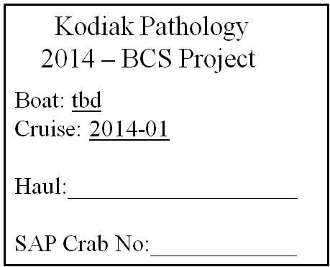6 – Prib Snow: HG-22/21, H-21, IH-21/20, IH-22/21, I-21, I-22, I-23, JI-21/20, JI-22/21, J-23

**Crab Target Size:**

*C. opilio* Males: ≤ 95 mm

*C. opilio* Females: ≤ 50 mm

*C. bairdi* Males: ≤113 mm

*C. bairdi* Females: ≤ 85 mm